**NATIONAL INSTITUTE OF TECHNOLOGY**

**RAIPUR**

**2023-2024**



*ELECTRONICS MEASUREMENT AND INSTRUMENTS*

**ASSIGNMENT:-**

# SUBMITTED TO:-

MR.Sujay Chakraborty Sir

**SUBMITTED BY:-**

Ch.Sasidhar Reddy

22116022

Third Semester

Electronics And Communication Engineering

ASSIGNMENT TOPICS:- 1) Describe The Construction Details And Principle Of Operation Of D'arsonval Galvanometer

2)Three Wattmeter Method, Two Wattmeter Method, One Wattmeter method.

3)Explain How Three Phase Power Can Be Measured Using Wattmeter.

4)Megger

5) Loading Effect Of Ohmmeter 6) AC Bridges:

*Maxwell's Bridge

* Hay Bridge

* Schering Bridge

*Wein Bridge

**1)Describe The Construction Details And Principle of Operation Of D'arsonval galvanometer?**

**Ans:-**

.

The D'Arsonval galvanometer is a type of instrument used for measuring electric current. It operates based on the principle of electromagnetic induction. Here are the construction details and the principle of operation of a D'Arsonval galvanometer:

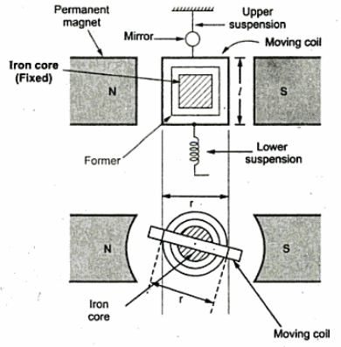

## Construction Of D'arsonval Galvanometer:-

* This Is a Moving Coil Permanent Magnet Type Instrument. The Coil Of Many Turns Wound On a Metal Former Is Suspended, So As To Move About Its Vertical Axis.
* The Coil Moves In The Air Gap Provided Between The Pole Pieces. The Air Gap Is About 1.5 mm.
* As The Coil Is Wound On A Non-Magnetic (Usually Aluminium) Former, The Damping Torque Is Provided By The Eddy Currents Induced In The Former During Motion Of The Coil.
* This Damping Is Very Efficient And The Instrument Is Dead Beat. The Damping Can Also Be Provided By Connecting A Low Resistance Across The Galvanometer And The Damping Can Be Obtained By Adjusting The Value Of The Resistance.
* The Coil Is Suspended By A Phosphor Bronze Filament Which Also Acts As A Lead For The Coil. The Other Lead Is A Flexible Spiral Filament At The Bottom Of The Coil. These Filaments Are Also Called Upper And Lower Suspensions.
* The Poles Of The Magnet Are Usually Cylindrical In Shape.
* By Having Cylindrical Poles. The Length Of Air Gap Is Reduced So That The Amount Of Flux Link- Ing With The Coil Is Increased, This Increases Sensitivity Of The Instrument And The Flux Between The Poles Becomes Radial.
* Moreover In A Radial Field, The Deflection Of The Coil Is Directly Proportional To The Current In The Coil And Therefore A Uniform Scale Is Obtained.

## Working Of D'Arsonval Galvanometer:-

* When The Current To Be Measured Is Made To Flow Through The Coil, A Deflecting Torque Proportional To The Product Of Flux Density, Current And Dimensions Of The Coil Makes The Coil To Rotate About Its Vertical Axis.
* Now The Suspension Filaments Produce Controlling Force And The Pointer Stops When The De- Flecting And Controlling Torques Equal Each Other. As The De- Flecting Torque Is Directly Proportional To The Current, The Amount Of Deflection Of The Coil Indicates The Magnitude Of Cur- Rent On Calibrated Scale.
* On Some Galvanometers, A Mirror Is Attached To The Moving System. A Light Beam Is Reflected From The Mirror On To A Glass Scale. As The Coil Is Deflected, The Light Beam Moves Over The Scale. The Scale Is About One (Or Half A) Meter Away From The Instrument.
* The Mirror Eliminates The Parallex. This Also Pro- Vides A High Sensitivity Of The Galvanometer. The Upper And Lower Suspensions Are Very Weak And Hence The Instrument Is Not Very Strong Mechanically, So The Galvanometer Needs To Be Handled Carefully.
* A Torsion Head Is Provided For Adjusting The Position Of Coil And Also For Zero Setting..

## CONVERSION OF D'ARSONVAL GALVANOMETER INTO AMMETER AND VOLTMETER:-

* The Basic D'Arsonval Galvanometer Can Be Converted Into An Ammeter (To Read Currents) By Connecting A Small Resistance In Parallel With The Instrument. This Resistance Is Called Shunt.
* The Value Of Shunt Is To Be Designed According To The Range Of The Currents Under Measurement.
* The Basic D'Arsonval Galvanometer Can Also Be Converted Into A Voltmeter (To Read Voltages) By Connecting A High Resistance In Series With The Instrument.
* This Resistance Is Called Multi- Plier. The Value Of The Multiplier Is To Be Calculated According To The Range Of The Voltage Under Measurement

**2)Three Wattmeter Method, Two Wattmeter Method, One Wattmeter Method.**

\***Three Wattmeter Method:-**

The 3-Wattmeter Method Is A Technique Used In Three-Phase Power Systems To Measure Power Consumption And Analyze Power Factor.

* In A Three-Phase System, There Are Three Conductors, And Each Conductor Has A Sinusoidal Voltage Waveform.
* The Power In A Three-Phase System Consists Of Active Power (Real Power), Reactive Power, And Apparent Power

**CONSTRUCTION:-**

* Connect Three Wattmeters To The Three Phases Of The System.
* Each Wattmeter Measures The Power In One Of The Phases

## POWER FACTOR:-

Calculate The Power Factor (PF) Using The Formula:

● PF=P/S

Determine The Phase Angle (Θ) Between Voltage And Current For Each Phase. The Arccosine Of The Power Factor Gives The Phase Angle

Θ=Cos^-1(PF)

The 3-Wattmeter Method Provides Accurate Measurements Of Power In A Threephase System And Allows For The Determination Of Power Factor And Power Distribution Among The Phases. It Is Commonly Used In Industrial Settings To Monitor And Control Power Consumption

### Three Wattmeter Diagram

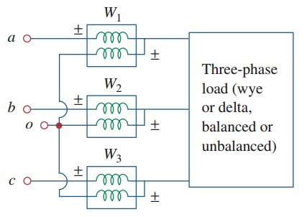

#### Two Wattmeter Method:-

The Two-Wattmeter Method Is A Technique Used In Three-Phase Power Systems To Measure Power Consumption And Analyze Power Factor.

● This Method Is Commonly Used In Balanced Loads Where The Three Phases Have Identical Impedances And The Load Is Symmetrical. ● It Is A Simpler Alternative To The Three-Wattmeter Method

#### Construction

● Connect Two Wattmeters To Two Of The Three Phases Of The System. For Convenience, The Wattmeters Are Usually Connected To The Two Phases With A 90-Degree Phase Difference.

**Power Factor**

Calculate The Power Factor (PF) Using The Formula:

PF=P/S

Determine The Phase Angle (Θ) Between Voltage And Current For Each Phase. The Arccosine Of The Power Factor Gives The Phase Angle:

Θ=COS^-1(PF)

The Two-Wattmeter Method Is Useful In Situations Where Using Three Wattmeters Might Be Impractical Or Cost-Prohibitive. It's Important To Note That The Load Must Be Balanced For This Method To Provide Accurate Results. The Accuracy Is Compromised In The Presence Of Unbalanced Loads Or Loads With Different Phase Angles.

#### TWO WATTMETER DIAGRAM:-

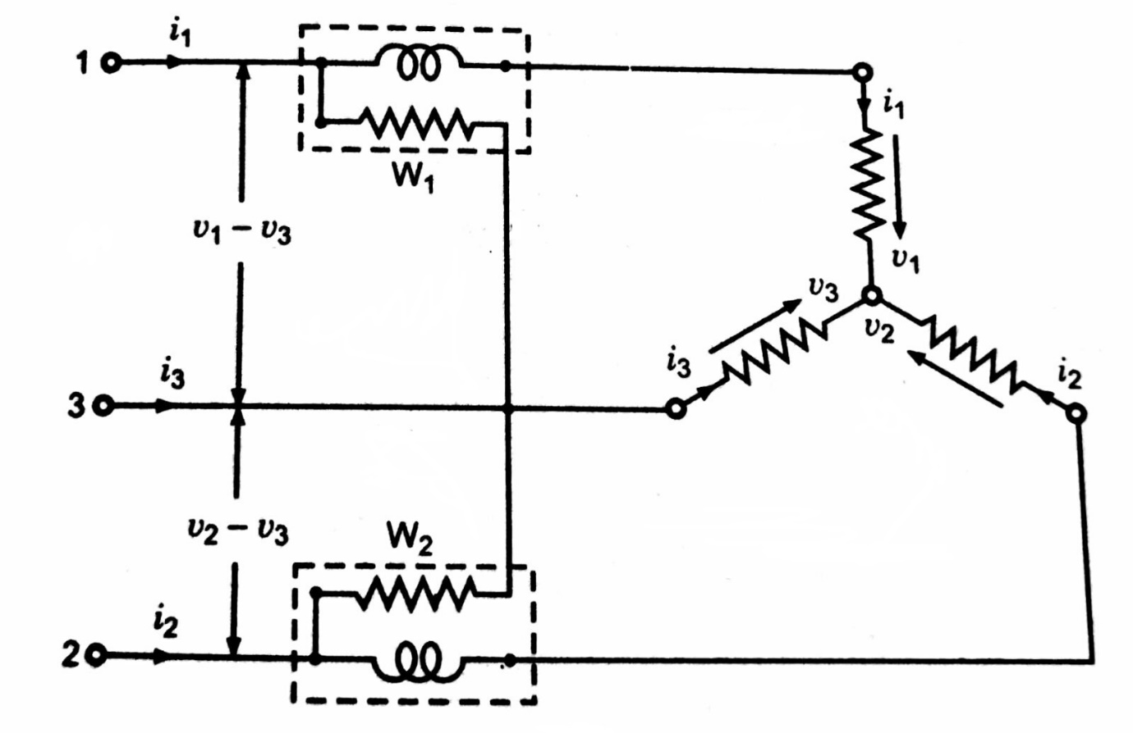

#### ONE WATTMETER METHOD:-

The One-Wattmeter Method Is Commonly Used To Measure Power In A Threephase AC Circuit When Only One Wattmeter Is Available.

* This Method Is Applicable When The Load Is Balanced, Meaning That The Impedances In Each Phase Are Equal.
* The One-Wattmeter Method Is Often Used In Power Systems And Industrial Applications Where Using Three Wattmeters May Not Be Practical.

#### ONE WATTMETER METHOD OF POWER MEASUREMENT

This Method Is Used Only For A Balanced Load. When A 3-Phase System Is Connected To A Balanced 3-Phase Load, Then The Entire Power Consumption Of The Load Can Be Determined By Using A Single Wattmeter

#### DAIGRAM FOR ONE WATTMETER METHOD:-

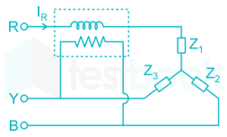

**Explain How Three Phase Power Can Be Measured Using Wattmeter.**

A Wattmeter Is An Instrument Used To Measure The Electrical Power Supplied In A Circuit. It Consists Of A Voltage Coil Connected Across The Load And A Current Coil Connected In Series With The Load. The Deflection Of The Pointer Is Proportional To The Magnetic Field Produced By The Two Coils, Which Is Nothing But Proportional To Power. A Wattmeter Can Measure Power In Single-Phase Circuits Directly. But In Order To Measure 3phase Power, One Or More Wattmeters Are Used. The Various Methods Available For The Measurement Of Power In 3-Phase Circuits Are:

1. One Wattmeter Method
2. Two Wattmeter Method
3. Three Wattmeter Method

The One Wattmeter Method Is Used Only For A Balanced Load. When A 3phase System Is Connected To A Balanced 3-Phase Load, Then The Entire Power Consumption Of The Load Can Be Determined By Using A Single Wattmeter. The Wattmeter Current Coil Is Connected In Series With Any One Of The Lines And Hence Carries The Full Line Current. The Voltage Coil Is Connected In Such A Way That, One End To The Line In Which The Current Coil Is Placed, The Other End Is Connected To The Remaining Two Lines Through An SPDT Switch, And Hence The Line Voltage Will Be Impressed On It. Here An SPDT Switch Is Used To Change The Voltage Coil Connection Between Two Phases. Hence, The Sum Of Readings Of The Wattmeter With Two Different Positions Of The Switch Will Give The Total Power Consumed By The Load. This Method Is Used Only For A Balanced Load. When A 3-Phase System Is Connected To A Balanced 3-Phase Load, Then The Entire Power Consumption Of The Load Can Be Determined By Using A Single Wattmeter. The Power Measurement In A 3-Phase System Using One Wattmeter Can Be Done Only When The Load Is Balanced. Any Slight Change In Load On Any Phase Produces A Significant Error In The Readings.

### MEGGER

A Megger Is A Type Of Electrical Test Equipment That Is Used To Measure Insulation Resistance. It Applies A High Voltage To The Circuit And Measures The Amount Of Current That Flows Through The Insulation. This Helps To Identify Potential Problems With The Insulation,Such As Damage Or Degradation. A Megger Meter Is A Tool That Is Used To Measure High Electrical And Insulation Resistance.It Is Also Referred To As A Megohmmeter 1. The Commonly Known Ohmmeter Measures Low Values Of Resistance Whereas A Megohmmeter Will Measure A Higher Range Of Several Mega Ohms By Passing High Voltage Into It 1. Megger Instruments Have Been Used Since The 1920s To Test A Variety Of Electrical Devices That Can Measure More Than 1000 Meg-Ohms.

### DIAGRAM

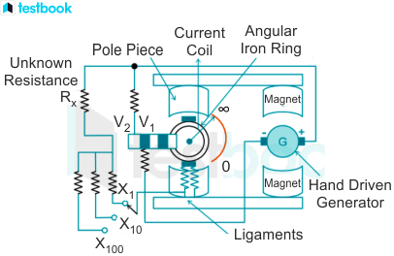

### LOADING EFFECT OF OHMMETER:-

The Loading Effect Of An Ohmmeter Refers To The Impact That The Measurement Device Has On The Circuit Or Component Being Measured. In The Case Of Ohmmeters, The Loading Effect Is Associated With The Introduction Of The Ohmmeter Into The Circuit And How It Affects The Resistance Measurement.

**Ideal Ohmmeter:**

* In An Ideal Situation, An Ohmmeter Should Have Infinite Internal Resistance (Ideally Open Circuit) So That It Does Not Draw Any Current From The Circuit Being Measured.

**Real Ohmmeter:**

* Practical Or Real Ohmmeters Have Finite Internal Resistance. When Connected To A Circuit, They Draw A Small Amount Of Current For The Measurement.

**Loading Effect:**

* The Loading Effect Occurs Because The Finite Internal Resistance Of The Ohmmeter Creates A Parallel Path For Current In The Circuit Under Test. This Additional Current Flow Affects The Accuracy Of Resistance Measurements, Especially In Lowresistance Circuits.

**Impact On Measurement:**

* In Low-Resistance Circuits, The Additional Current Drawn By The Ohmmeter Can Significantly Affect The Measured Resistance. This Is Because The Current Through The Ohmmeter Becomes Comparable To The Current Through The Circuit Being Measured.

**Effect On High-Resistance Circuits:**

* In High-Resistance Circuits, The Loading Effect Is Usually Negligible Because The Additional Current Drawn By The Ohmmeter Is Small Compared To The Current Through The Circuit.

**Compensating For Loading Effect:**

* In Critical Applications, Especially When Measuring Very Low Resistances, Compensating For The Loading Effect May Be Necessary. This Can Involve Using Correction Factors Or Employing Specialized Measurement Techniques.

Understanding The Loading Effect Is Essential For Accurate Resistance Measurements, Particularly In Circuits With Low Resistance Values. Highquality Ohmmeters With High Input Impedance Help Mitigate The Loading Effect And Provide More Accurate Measurements.

### AC BRIDGES:-

MAXWELL’S BRIDGE

HAY BRIDGE

SCHERING BRIDGE

WEIN BRIDGE

#### 1) MAXWELL’S BRIDGE:-

Maxwell's Bridge Is An Electrical Circuit Used For The Measurement Of Inductance. It Was Named After James Clerk Maxwell, A Scottish Physicist Who Made Significant Contributions To The Field Of Electromagnetism.

The Primary Purpose Of Maxwell's Bridge Is To Determine The Inductance Of An Unknown Coil Or Inductor. The Bridge Is Particularly Useful For Measuring Inductance In Situations Where The Resistance Of The Inductor Is Not Negligible, As It Takes Into Account Both The Resistance And Inductance Of The Coil.

The Basic Configuration Of Maxwell's Bridge Includes Resistors, Capacitors, And An Inductor. The Bridge Is Balanced When The Ratio Of The Inductor's Reactance To The Resistance In The Bridge Arm Is Equal To The Ratio Of The Capacitor's Reactance To The Resistance In Another Arm Of The Bridge.

While Maxwell's Bridge Was Historically Significant And Played A Role In Early Electrical Measurements, More Modern Methods And Instruments, Such As Impedance Analyzers, Have Largely Replaced Its Practical Use In Contemporary Electronics And Engineering. However, It Still Holds Educational Value In Understanding The Principles Of Bridge Circuits And Their Applications In Measuring Electrical Parameters.

#### DAIAGRAM:-

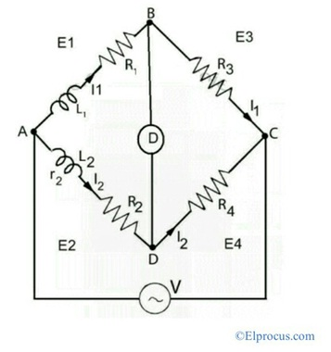

#### HAY BRIDGE:-

The Hay Bridge Is Another Type Of Bridge Circuit Used In Electronics For The Measurement Of Inductance, Similar To The Maxwell Bridge. Like Maxwell's Bridge, The Hay Bridge Is Named After A Physicist, In This Case, Walter Hay.

Here's A Basic Description Of The Hay Bridge:

**Purpose:**

* The Primary Purpose Of The Hay Bridge Is To Measure The Inductance Of An Unknown Coil Or Inductor.

**Components:**

* The Hay Bridge Consists Of Resistors, Capacitors, And The Unknown Inductor. It Typically Includes A Standard Capacitor And A Variable Resistor.

**Working Principle:**

* The Bridge Is Balanced When The Ratio Of The Reactance Of The Unknown Inductor To The Resistance In One Arm Is Equal To The Ratio Of The Reactance Of The Standard Capacitor To The Resistance In Another Arm. This Balanced Condition Is Detected Using A Null Detector.

**Balancing Equation:**

* The Balancing Equation For The Hay Bridge Is Similar To That Of The Maxwell Bridge And Involves The Reactances And Resistances In The Bridge Arms.

While The Hay Bridge Was Historically Used For Inductance Measurements, Like Maxwell's Bridge, Modern Instrumentation And Impedance Analyzers Have Largely Replaced Its Practical Use In Current Engineering And Electronics. These Bridges Are Still Valuable For Educational Purposes To Understand The Principles Of Bridge Circuits And Their Applications In Measuring Electrical Parameters.

#### DIAGRAM:-

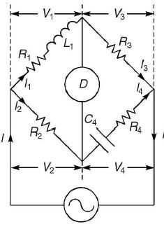

#### EQUATION:-

The Basic Configuration Of The Hay’s Bridge Includes Three Components:

1)The Unknown Self-Inductance Coil (L X) A Known Reference Inductance (L S) A Variable Resistor ®

2) The Bridge Is Balanced When The Ratio Of The Self-Inductance To The Reference Inductance Is Equal To The Ratio Of The Resistances In The Arms Of The Bridge

= L X /L S = R 1 /R 2

### SCHERING BRIDGE:-

The Schering Bridge, Also Known As The Schering-Kerr Bridge, Is An Electrical Circuit Used For The Measurement Of Capacitance. This Bridge Configuration Was Developed By German Engineer Georg Simon Ohm And Later Modified By German Physicist Walter Schottky.

Here Are The Key Features And Components Of The Schering Bridge:

**Purpose:**

* The Primary Purpose Of The Schering Bridge Is To Measure The Capacitance Of An Unknown Capacitor. It Is Particularly Useful For Measuring Small Capacitances With High Precision.

**Components:**

* The Schering Bridge Consists Of Resistors, Capacitors, And The Unknown Capacitor. It Includes A Standard Capacitor, A Variable Resistor, And A Source Of Alternating Current (AC).

**Working Principle:**

* The Bridge Is Balanced When The Ratio Of The Capacitance Of The Unknown Capacitor To The Resistance In One Arm Is Equal To The Ratio Of The Capacitance Of The Standard Capacitor To The

Resistance In Another Arm. The Bridge Is Typically Operated With An AC Source.

**Balancing Equation:**

* The Balancing Equation For The Schering Bridge Involves The Capacitances And Resistances In The Bridge Arms.

**Use Of AC Source:**

* The Schering Bridge Often Operates With An AC Source To Avoid The Effects Of Electrolysis That Can Occur With DC In Capacitance Measurements.

The Schering Bridge, Like Other Bridge Circuits, Allows For Precise Measurement Of Electrical Components. While Modern Capacitance Meters And Impedance Analyzers Have Largely Replaced Bridge Circuits In Practical Applications, The Schering Bridge Remains An Important Part Of The History Of Electrical Measurements And Is Still Studied For Educational Purposes.

### DIAGRAM:-

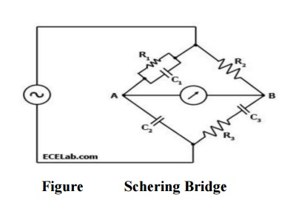

### WEIN BRIDGE:-

The Wein Bridge Is An Electrical Circuit Commonly Used In Electronics For The Measurement Of Frequency. It Was Developed By Max Wien, A German Physicist, And It Is Often Employed In Audio Frequency Applications. The Primary Use Of The Wein Bridge Is In The Design Of Oscillators, Particularly Audio Oscillators.

Key Features Of The Wein Bridge:

**Purpose:**

* The Wein Bridge Is Designed To Measure The Frequency Of An AC Signal Accurately. It's Commonly Used In Audio Applications And Signal Generators.

**Components:**

* The Basic Components Of A Wein Bridge Include Resistors, Capacitors, And An Operational Amplifier. It Uses Both Positive And Negative Feedback To Create A Stable Oscillation.

**Working Principle:**

* The Bridge Operates On The Principle Of Positive Feedback, Where A Fraction Of The Output Voltage Is Fed Back In Phase With The Input. This Positive Feedback, Combined With The Appropriate RC (Resistor-Capacitor) Network, Leads To Stable Oscillations At A Specific Frequency.

**Balancing Equation:**

* The Balancing Condition For The Wein Bridge Is Determined By The Ratio Of Resistances And Capacitors In The Feedback Network.

**Frequency Of Oscillation:**

* The Frequency Of Oscillation In A Wein Bridge Is Primarily Determined By The Values Of The Resistors And Capacitors In The Feedback Network.

Wein Bridge Oscillators Are Known For Their Simplicity And Ease Of Frequency Control. They Are Often Used In Audio Signal Generators And Frequency-Sensitive Applications. While More Modern Oscillator Designs Have Been Developed, The Wein Bridge Oscillator Remains A Classic And Educational Example In The Study Of Electronic Circuits.

### DIAGRAM:-

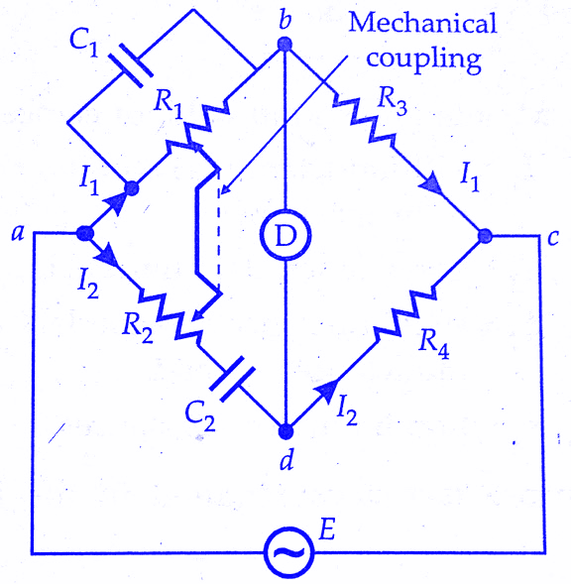s